**Comparison of Bee Colony Decline by State to Various Industrial and Environmental Factors**

**Introduction**

Since the late 1990s, beekeepers around the world have observed the mysterious and sudden disappearance of bees, and report unusually high rates of decline in honeybee colonies.

Bees make more than honey – they are key to food production because they pollinate crops. Bumblebees, other wild bees, and insects like butterflies, wasps, and flies all provide valuable pollination services. A third of the food that we eat depends on pollinating insects; vegetables like zucchini, fruits like apricot, nuts like almonds, spices like coriander, edible oils like canola, and many more. In Europe alone, the growth of over 4,000 vegetables depends on the essential work of pollinators. Currently, more and more of the bees are dying. The bee decline affects mankind too. Our lives depend on theirs. 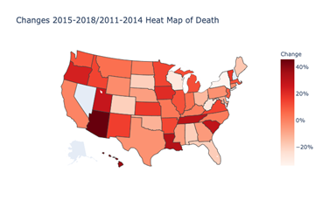

Comparison of bee colony decline to population density, weather, and telephone tower location density, through statistical analysis and data visualization, will reveal correlation and call for further research for the relationships between bee die off, weather and population density.

**Does Increased Population Density lead to Increased Bee Colony loss?**

Bee colony decline was first compared to population density. In figure 2, the top 5 states of bee colony lost from 2015-2018 have been plotted. California, North Dakota, Texas, Washington, and Idaho measuring from first to fifth respectively. Figure 2A shows the number of lost bee colonies in the top 5 most dense states with California removed due to the state value being deemed an outlier. A t-test was used to compare the means between bee colonies lost and state population density. The p-value returned was 0.0000321, meaning evidence has been provided for a strong correlation between the two parameters.

The data was limited to the state level, a future consideration is to refine this down to the county level to possibly achieve a greater understanding of the relationship and to allow the inclusion of 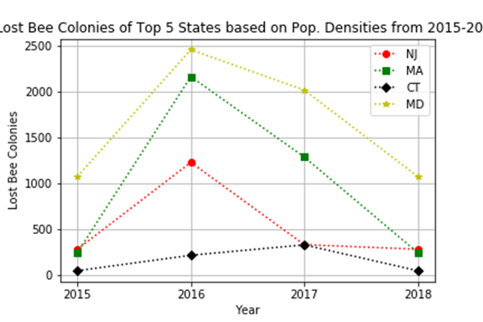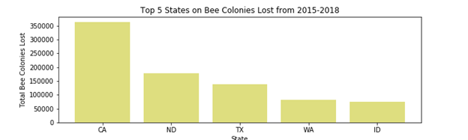larger states such as California, which accounts for an enormous amount of bee colony death every year. The top 5 states of bee colony loss by population density were New Jersey, Massachusetts, Connecticut, and Maryland. Based on the data visualizations, and statistical test there is evidence for a strong correlation that shows the greater the states population density, the greater the loss of bee colonies.

**Does Climate affect the Survival of Bee Colonies?**

Next, bee colony decline was compared to the survival of bee colonies. For this comparison bee colony death, and environment were compared to each other by regions of the United States. The regions were divided by South Atlantic, Mountain, Pacific, New England, East South Central, West Central South, Midwest and East North Central. The regions were measures in terms of their environment which is a factor of temperature, and proximity to water.

The Environment factor was plotted against the total amount of bee colonies death in figure 3. As figure 3 shows, bee colonies survive the best when in warm temperatures and close to bodies of water. The limitations of our conclusions are due to a lack of statistical testing for significant relationships. Based on the data gathered, and visualizations created there is evidence for a positive correlation for the survival of bee colonies when they are in a warm environment and located near bodies of water, whether it be an ocean or lake. 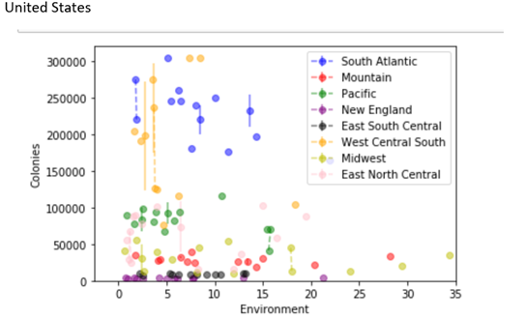

**Does the Towerphone Tower Count in a State Affect Bee Colony Survival Rate?**

Bee colony decline was next compared to the number of cell phone towers within a state. The expected relationship was that as cell phone tower count increased within a state the decline of bee colonies

would increase. Figure 4 helps visualize the number of cell phone towers per state, and to understand where the greatest loss of bee colonies should be expected. After using a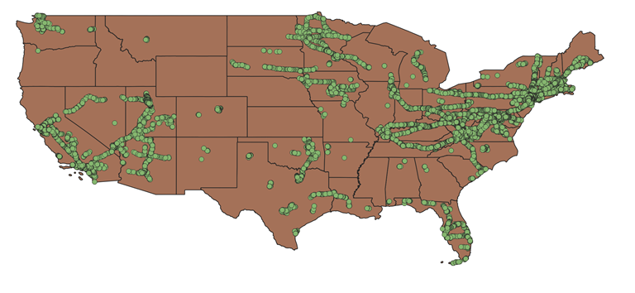



correlation test to compare the number of towers in a state to the average percent loss of bee colonies within the years 2015-2018 it was concluded that there was no relationship between the two. Figure 4A shows the scatterplot with a correlation line plotted. The r-value returned was 0.02.

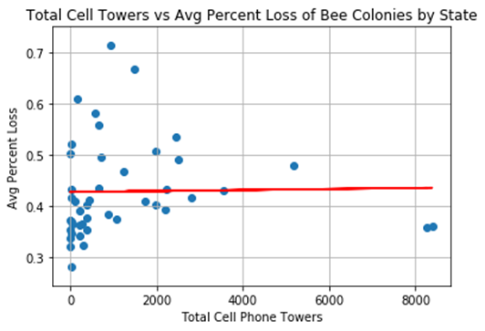

The correlation line shows the randomness between the two. The limitations of the conclusion are based on that the data is only available at the state level. Being able to define the relationship at the county level would be useful in allowing more detail in big states, such as Texas or California where any two parts of the state compared could be vastly different and not tell the same story. Another limitation, which is similar, is that because we’re comparing at the state level there is a high possibility that any relationship seen is due to spurious correlation(big states have big loss, small states have small loss).

**Conclusions**

The research provided suggest that future research into bee colony decline should be directed at climate, and population density. Climate, and population both showed a relationship with the die off of bee colonies within states. A closer look should also be taken at bee survival and water sources. As the relationship we used does not independently test between temperature, and water source proximity. As the installation of 5G progresses for cell towers it would be of great interest to our group to reexamine that area of research.